**Objective Questions**:

1. What is the total no. of tables present in the data?

* 2

1. What is the total no. of attributes present in the data?

* There are total 22 attributes in 2 sheets of which one is attribute is common **(CountryCode)**

1. How many categorical columns are there in the data? [Search about categorical and continuous data, and try to answer this question]

* There are 12 categorical columns in the date. They are

1. CountryCode
2. City
3. Locality
4. LocalityVerbose
5. Cuisines
6. Currency
7. Has_Table_booking
8. Has_Online_delivery
9. Is_delivering_now
10. Switch_to_order_menu
11. Price_range
12. Country Name

1. The data consists of some inconsistent and missing values so ensure that the data used for further analysis is cleaned.

* There were some missing values (blanks) in cuisine columns and 0 value in latitude, longitude and Average_Cost_for_two column. The missing value is ignored because we are getting some important data in other columns.

1. Using the LookUp functions, fill up the countries in the original data using the country code.

* Implemented by using VLookup function  
  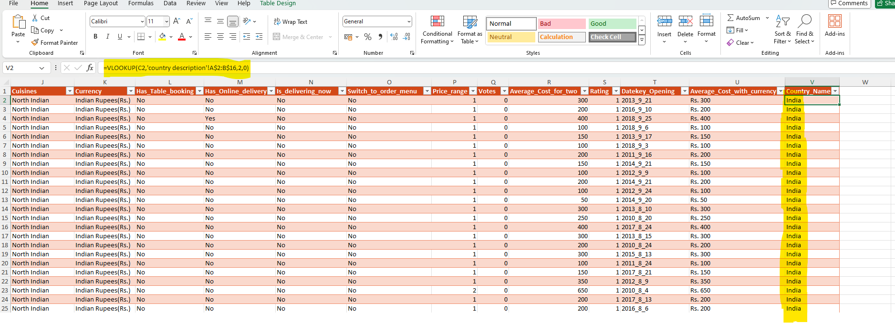

1. Create a table to represent the number of restaurants opened in each country.

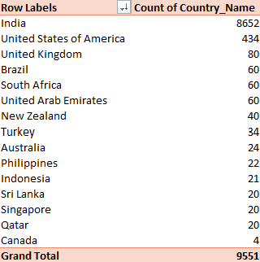

1. Also, the management wants to look at the number of restaurants opened each year, so provide them with something here.

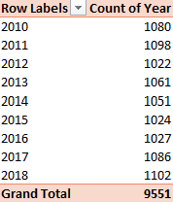

1. What is the total number of restaurants in India in the price range of 4?

* 388

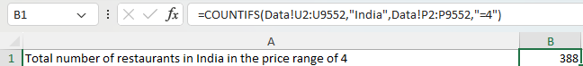

1. What is the average number of voters for the restaurants in each country according to the data?

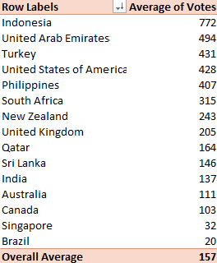

1. Calculate the average rating for all the restaurants that have price_range < 4 and provide online delivery. Use only the “IF” function, Logical Operators, and Aggregation functions to solve this problem. **[Note: Don’t use Conditional aggregation in this question.]**

* 3.273812



1. Using Conditional formatting highlight the rows of restaurants that are located in the countries or cities that you’ve suggested to the management for opening new restaurants.

* Implemented by creating a new rule in conditional Formatting  
  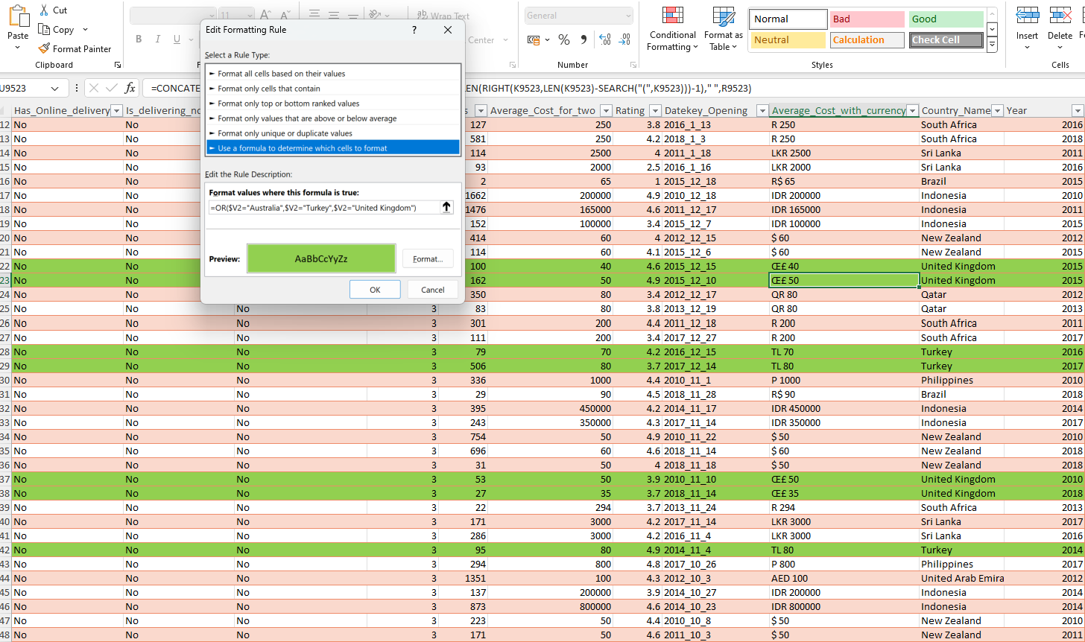

1. Create a new customized price column that consists of the abbreviation/symbol of the currency along with the Average_cost_for_two value. [Use string operations to do this task]

* Implemented using CONCATENATE function.

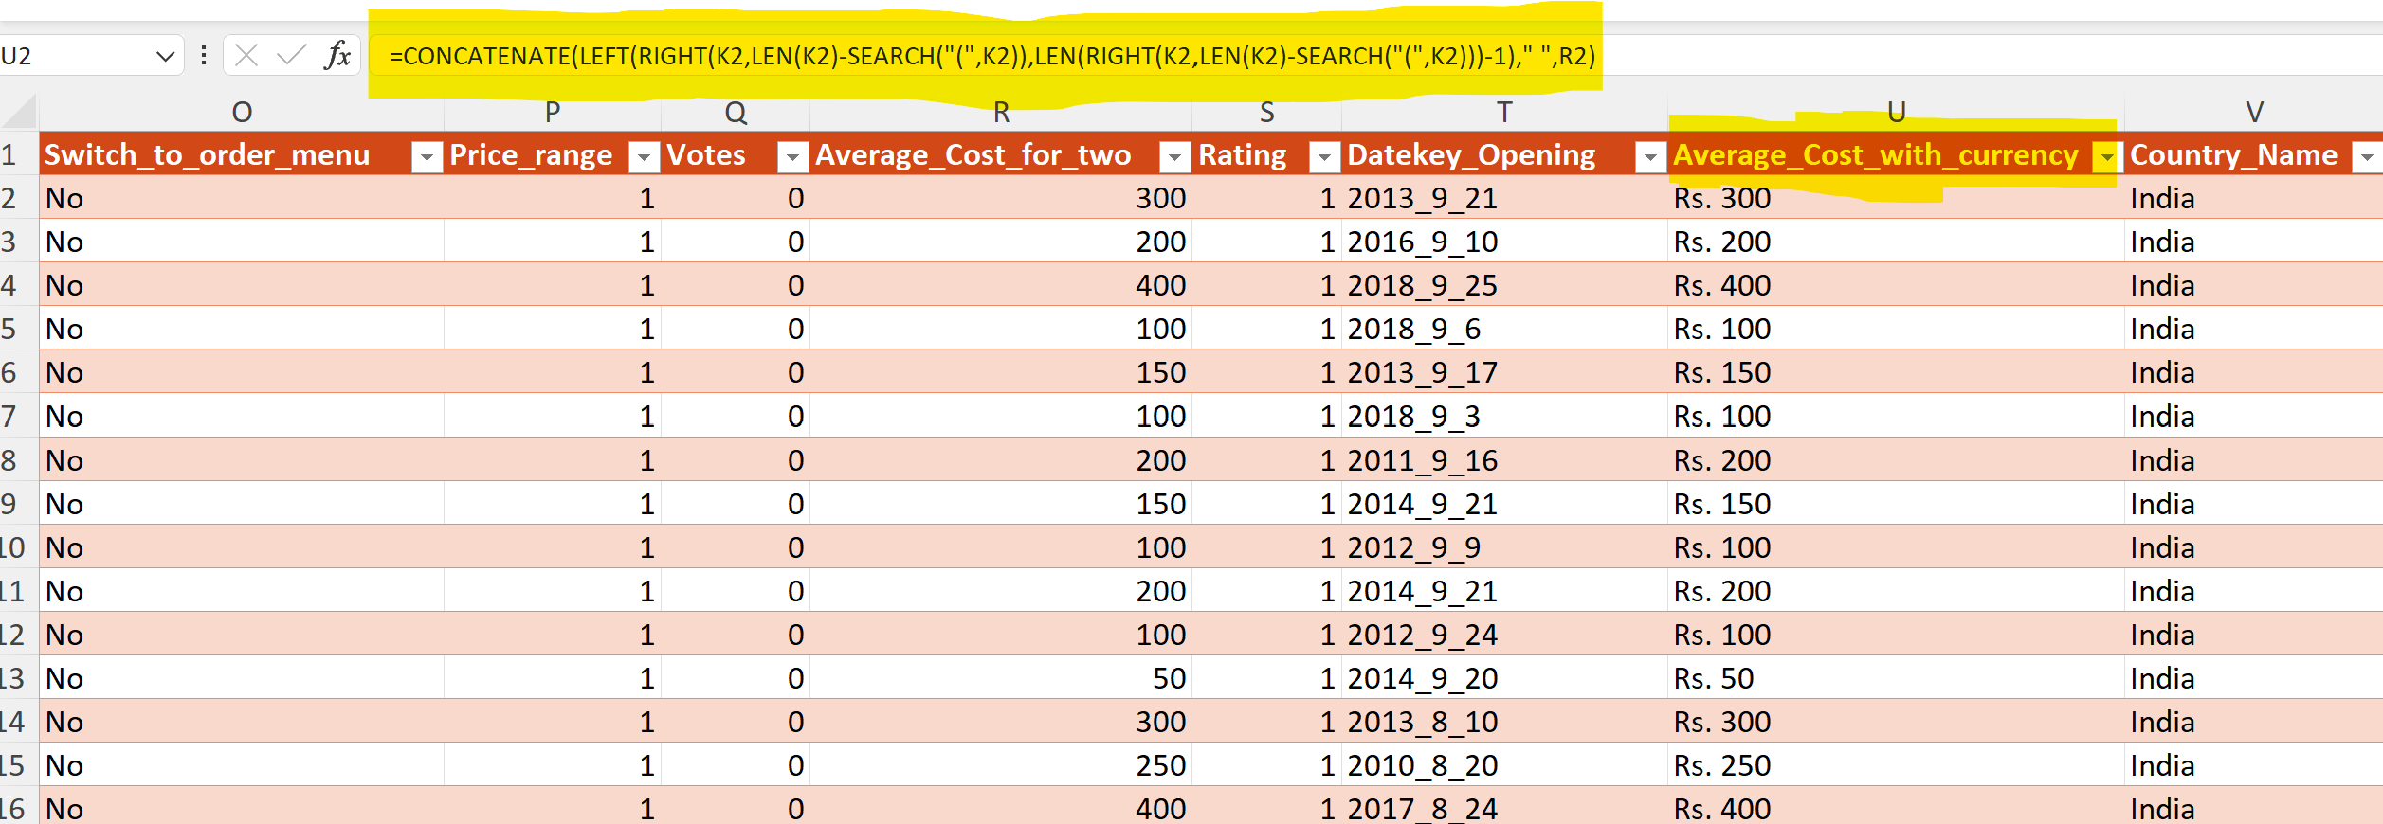

1. How can you create an array formula in Excel or Google Sheets to count the number of restaurants listed that do not offer online delivery, are in the lowest price range, and have an average cost for two people less than or equal to 250 Indian Rupees?

* 1694 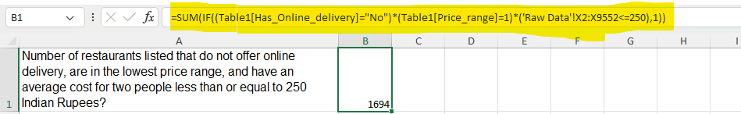

**Subjective Question:**

1. Suggest a few countries where the team can open newer restaurants with lesser competition. Which visualization/technique will you use here to justify the suggestions?

* Below are the key Indicators used to determine new countries for Zomato to open new restaurants.

|  |  |  |  |  |
| --- | --- | --- | --- | --- |
| **Row Labels** | **Average of Price_range** | **Average of Rating** | **Count of RestaurantID** | **Average of Votes** |
| India | 1.72 | 2.77 | 8652 | 137.21 |
| United States of America | 2.05 | 4.01 | 434 | 428.22 |
| Australia | 2.13 | 3.66 | 24 | 111.42 |
| Canada | 2.50 | 3.58 | 4 | 103.00 |
| United Kingdom | 2.75 | 4.10 | 80 | 205.49 |
| Turkey | 2.82 | 4.30 | 34 | 431.47 |
| Sri Lanka | 2.85 | 3.87 | 20 | 146.45 |
| Indonesia | 2.95 | 4.30 | 21 | 772.10 |
| New Zealand | 3.15 | 4.26 | 40 | 243.03 |
| United Arab Emirates | 3.22 | 4.23 | 60 | 493.52 |
| Philippines | 3.36 | 4.47 | 22 | 407.41 |
| Brazil | 3.40 | 3.85 | 60 | 19.62 |
| South Africa | 3.58 | 4.21 | 60 | 315.17 |
| Qatar | 3.65 | 4.06 | 20 | 163.80 |
| Singapore | 3.65 | 3.58 | 20 | 31.90 |
| **Grand Total** | **1.80** | **2.89** | **9551** | **156.91** |

Criteria used

* Restaurant Count < 100
* Average Price range < 3
* Average Rating > 4
* Average Votes > 200

On applying this criteria, the following three countries are selected

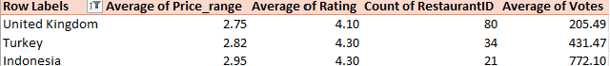

1. Come up with the names of States and cities in the suggested countries suitable for opening restaurants.

* On Analysing at the city level I have shortlisted the below cities as their average price range is not more than 3 and their average rating in more the 4.25.
* London
* Ankara
* Istanbul
* Jakarta

|  |  |  |  |  |
| --- | --- | --- | --- | --- |
| **Row Labels** | **Average of Price_range** | **Average of Rating** | **Count of RestaurantID** | **Average of Votes** |
| **United Kingdom** | **2.75** | **4.10** | **80** | **205.49** |
| Birmingham | 2.40 | 3.73 | 20 | 69.65 |
| Edinburgh | 2.90 | 4.09 | 20 | 112.30 |
| London | 3.00 | 4.54 | 20 | 436.20 |
| Manchester | 2.70 | 4.05 | 20 | 203.80 |
| **Turkey** | **2.82** | **4.30** | **34** | **431.47** |
| Ankara | 2.80 | 4.31 | 20 | 131.35 |
| ÛÁstanbul | 2.86 | 4.29 | 14 | 860.21 |
| **Indonesia** | **2.95** | **4.30** | **21** | **772.10** |
| Bandung | 3.00 | 4.20 | 1 | 22.00 |
| Bogor | 2.50 | 3.85 | 2 | 971.00 |
| Jakarta | 3.00 | 4.36 | 16 | 742.69 |
| Tangerang | 3.00 | 4.30 | 2 | 1183.50 |
| **Grand Total** | **2.80** | **4.18** | **135** | **350.54** |

1. According to the countries you suggested, what is the current quality regarding ratings for restaurants that are open there?

* Indonesia: 4.30

Turkey: 4.30

UK: 4.10



1. Also, what is the current expenditure on food in the suggested countries, so we can keep our financial expenditure in control?

* Below is the average cost of two in INR for the selected countries
* United Kingdom: INR 5060
* Turkey: INR 215
* Indonesia: INR 1430

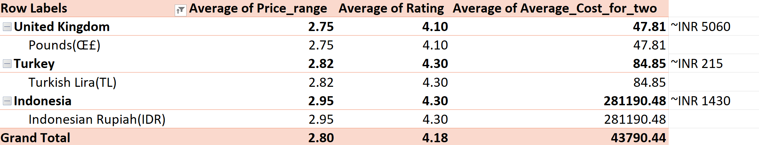

1. Come up with the names of restaurants from the recommended states that are our biggest competitors and also those that are rated in the lower brackets, i.e. 1-2 or 2-3.

* Recommended restaurants from Jakarta

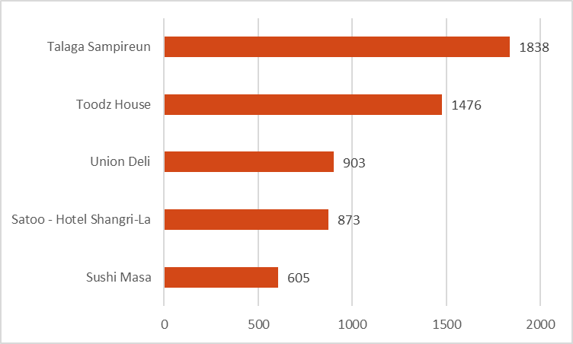

* Recommended restaurants from Istanbul

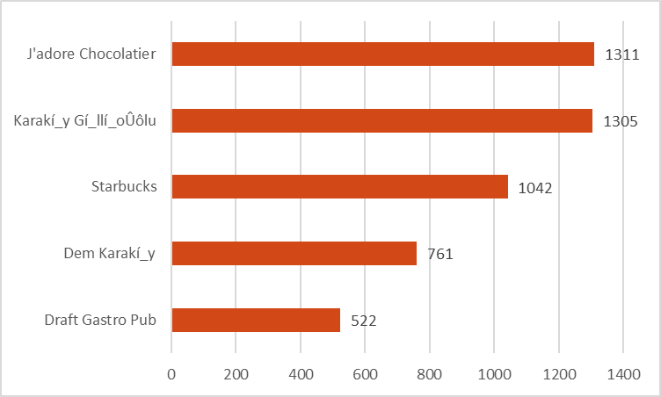

* Recommended restaurants from Ankara

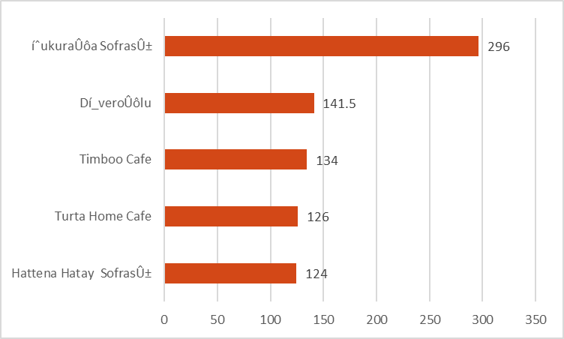

* Recommended restaurants from Ankara

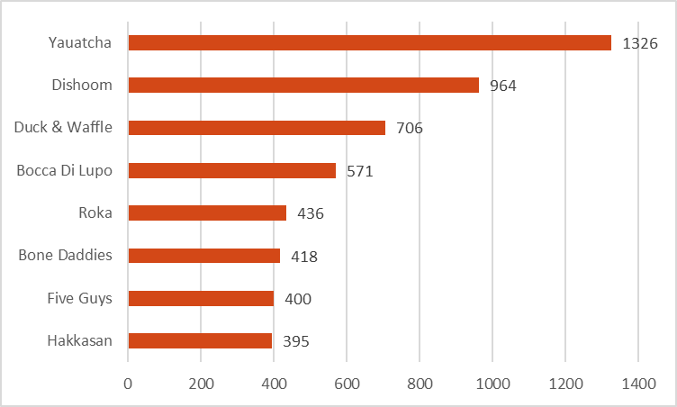

1. Which cuisines should we focus on in the newer restaurants to get better feedback? Does the choice of cuisines affect the restaurant ratings?

* Top cuisines from the selected cites

By Rating

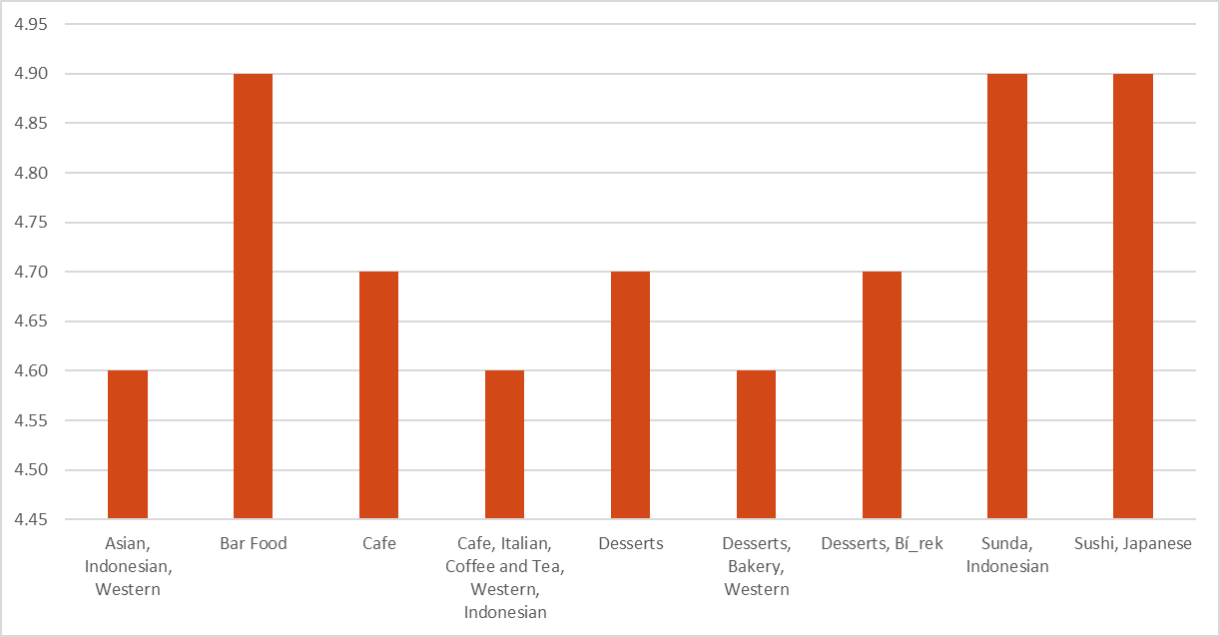

By Average Votes

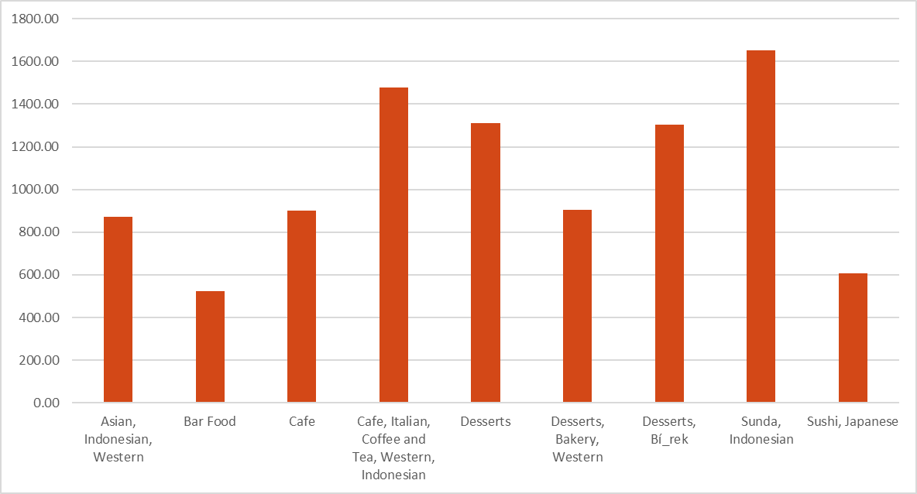

Criteria used Votes > 500

Average Rating > 4.5

Yes, Choice of cuisines affect the restaurant ratings as highest rated cuisine are getting the most votes. Therefore, it increases the restaurants rating as well.

1. According to our current data, should we go for online delivery and table booking? Does that affect the customer’s ratings?

* Yes, Online delivery and Table bookings are affecting the customer. The customer votes count as well average rating are better for the restaurants that provides these facilities.





1. Should the team keep the rate of cuisines higher? Will that affect the feedback? According to our data are the rates of cuisines and ratings, correlated?

* Yes, As per our data, higher the price higher is the average Customer rating.



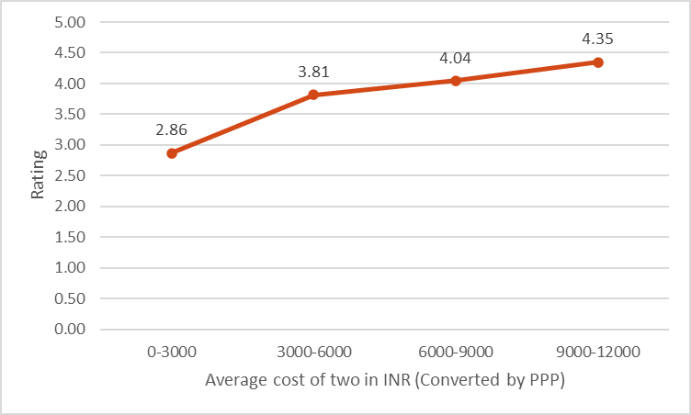

1. What is the distribution of the number of restaurants of different price ranges in all the countries?





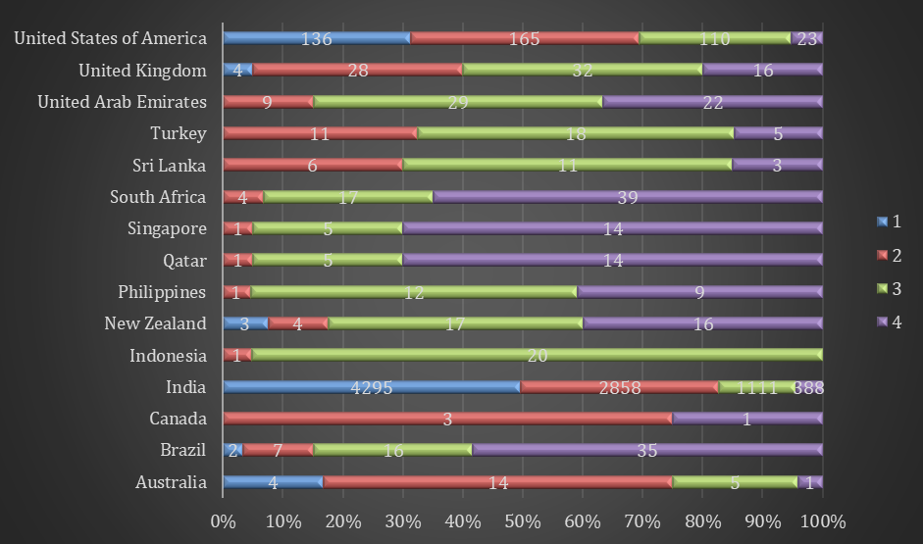

1. Explain your approach in brief for suggesting countries/cities in order to open new restaurants, if the objective and subjective questions would have not been given to assist you.

* Analyse the Key Performance Indicators (KPIs). They were
* Price Range :- The location should not be highly expensive, ensuring that operating costs are manageable.
* Average Votes Count :- A higher number of votes indicates a strong visitor count, suggesting a popular area.
* Average Rating :- A better average rating reflects higher customer satisfaction, which is crucial for customer retention.
* Restaurant Count :- The area should not be saturated with restaurants, providing ample room for growth in new markets.

|  |  |  |  |  |
| --- | --- | --- | --- | --- |
| **Row Labels** | **Average of Price_range** | **Average of Rating** | **Count of RestaurantID** | **Average of Votes** |
| India | 1.72 | 2.77 | 8652 | 137.21 |
| United States of America | 2.05 | 4.01 | 434 | 428.22 |
| Australia | 2.13 | 3.66 | 24 | 111.42 |
| Canada | 2.50 | 3.58 | 4 | 103.00 |
| United Kingdom | 2.75 | 4.10 | 80 | 205.49 |
| Turkey | 2.82 | 4.30 | 34 | 431.47 |
| Sri Lanka | 2.85 | 3.87 | 20 | 146.45 |
| Indonesia | 2.95 | 4.30 | 21 | 772.10 |
| New Zealand | 3.15 | 4.26 | 40 | 243.03 |
| United Arab Emirates | 3.22 | 4.23 | 60 | 493.52 |
| Philippines | 3.36 | 4.47 | 22 | 407.41 |
| Brazil | 3.40 | 3.85 | 60 | 19.62 |
| South Africa | 3.58 | 4.21 | 60 | 315.17 |
| Qatar | 3.65 | 4.06 | 20 | 163.80 |
| Singapore | 3.65 | 3.58 | 20 | 31.90 |
| **Grand Total** | **1.80** | **2.89** | **9551** | **156.91** |

Criteria used

* Restaurant Count < 100
* Average Price range < 3
* Average Rating > 4
* Average Votes > 200

On applying this criteria, the following three countries are selected

